INTRODUCING THE ACCUPRINTER™

FOR BRANDING OF EGGS AND TRACEBACK

MEYHEN-HPT is now offering the ACCUPRINTER™ to imprint eggs with a logo or up to four lines of text or numeric data at a cost approximating 0.5 cents per dozen.

The ACCUPRINTER™ offers brand identification and positive trace-back for product differentiation from generics and for enhanced consumer assurance of safety.

Imprints including logos and text can be changed using a hand-held pad with remote wireless connectivity. Different imprints can be selected for specific packers depending on product.

FDA-approved red and pink ink cartridges are currently available. ACCUPRINTER™ inks are impermeable to moisture and imprints will not smudge if post-pack condensation occurs.

The ACCUPRINTER™ is compatible with MOBA, Diamond and Staalkat packers and can be relocated within minutes using pre-mounted brackets and connectors.

Specially designed cartridges provide approximately 200,000 imprints and are available at either $85 or $95 depending on contract option.

Two alternative contract options are offered to suit the requirements of a packing plant with respect to product range and volume:-

OUTRIGHT PURCHASE

ACCUPRINTERS are delivered and installed at a 2019-2020 cost of $8,000 per unit. Payment of 50 percent with order, 35 percent on installation and the remaining 15 percent, 30 calendar days thereafter. Ink cartridges (6 per ACCUPRINTER™) will be supplied at $85 each held for a 3-year period after installation. A maintenance contract will be offered.

ROYALTY BASIS

ACCUPRINTERS are supplied against a one-time 2019-2020 payment of $1,600 with 50 percent due with order and the remaining 50 percent on installation. Cartridges are purchased at $95 each held for a 3-year period after installation. ACCUPRINTERS remain the property of Meyhen and are maintained by the supplier.

To review contract options and to project the cost of imprinting based on plant throughput, packing equipment or to review samples or arrange an in-plant demonstration contact Israel Sar-El, [ceo.int@htp-inc.com](mailto:ceo.int@htp-inc.com) or (203) 974 3910.

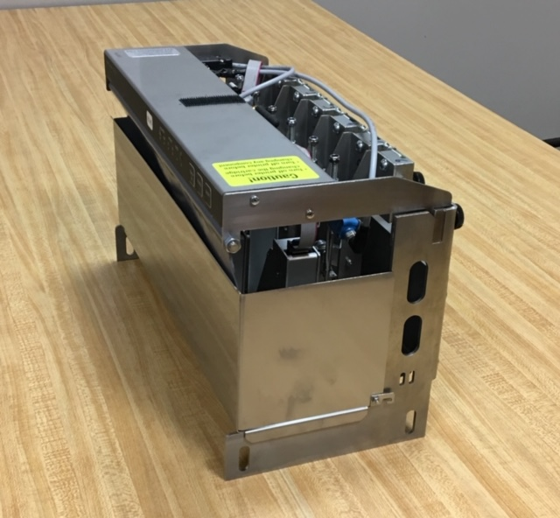

ACCUPRINTER

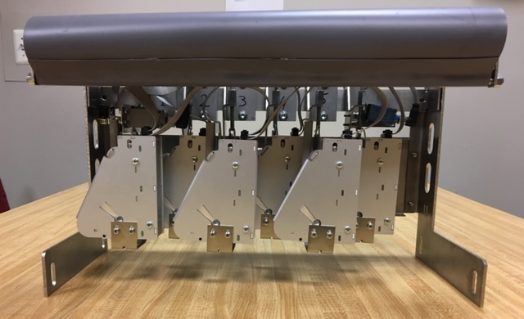

Interior view of ACCUPRINTER showing six staggered magazines for printer cartridges feeding printer heads

